**Practical No - 11**

**Aim** : Classification problems.

**Solution** : Once you have your data set loaded, all the tabs are available to you. Click on the ‘Classify’ tab.

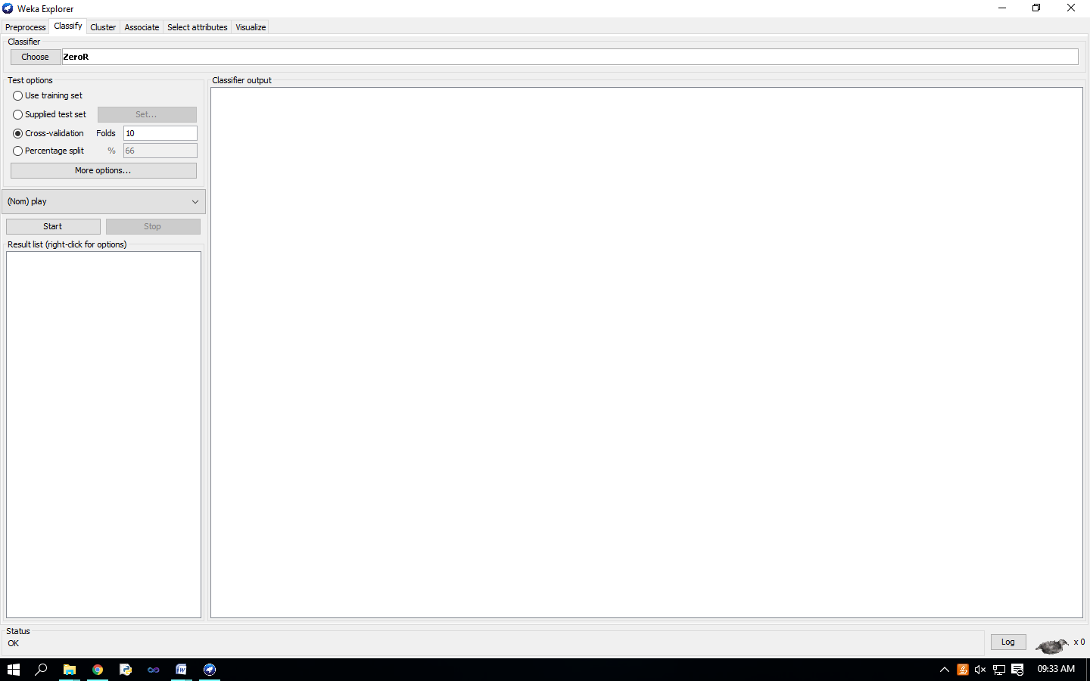 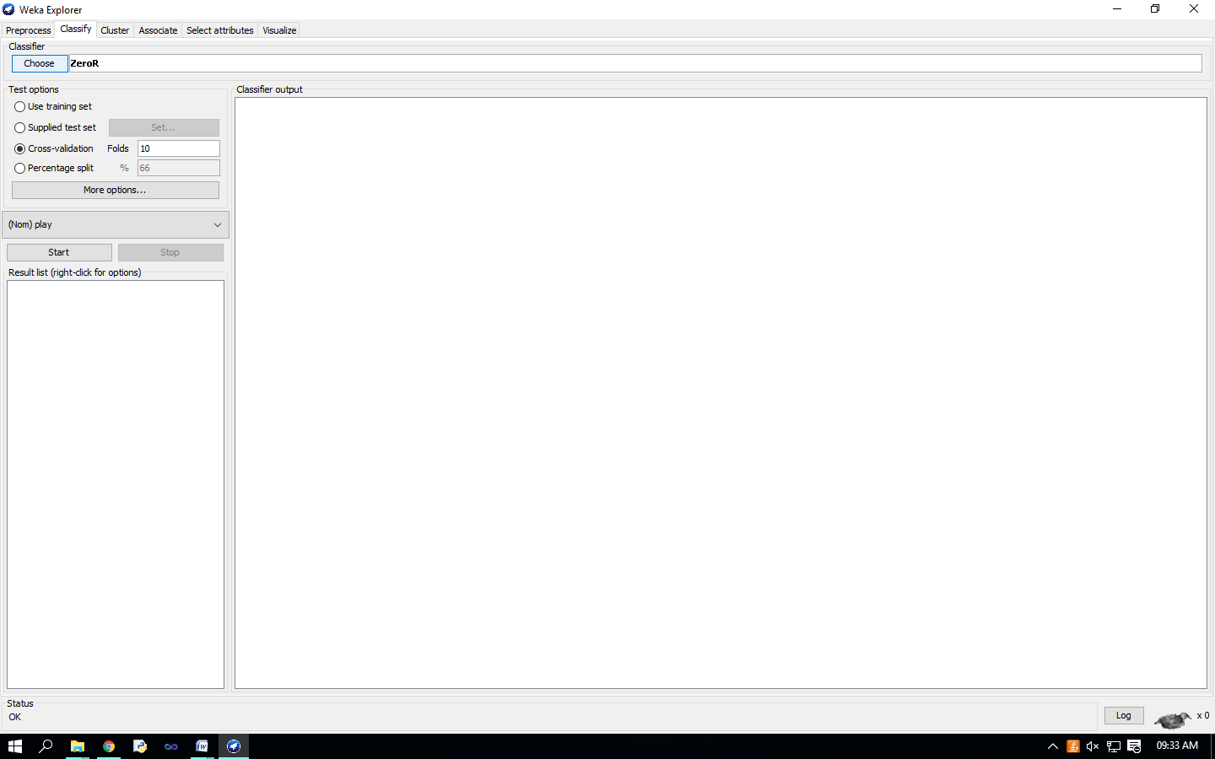

Click on ‘Choose’ button in the ‘Classifier’ box just below the tabs and select C4.5 classifier WEKA   Classifiers   Trees   J48. 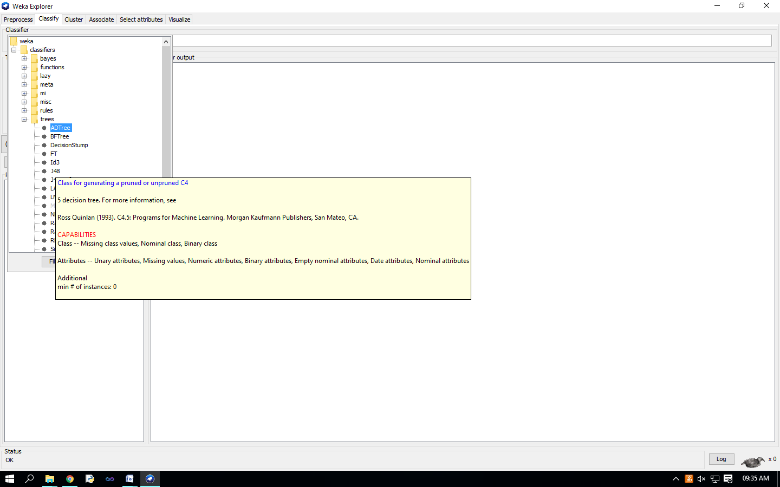 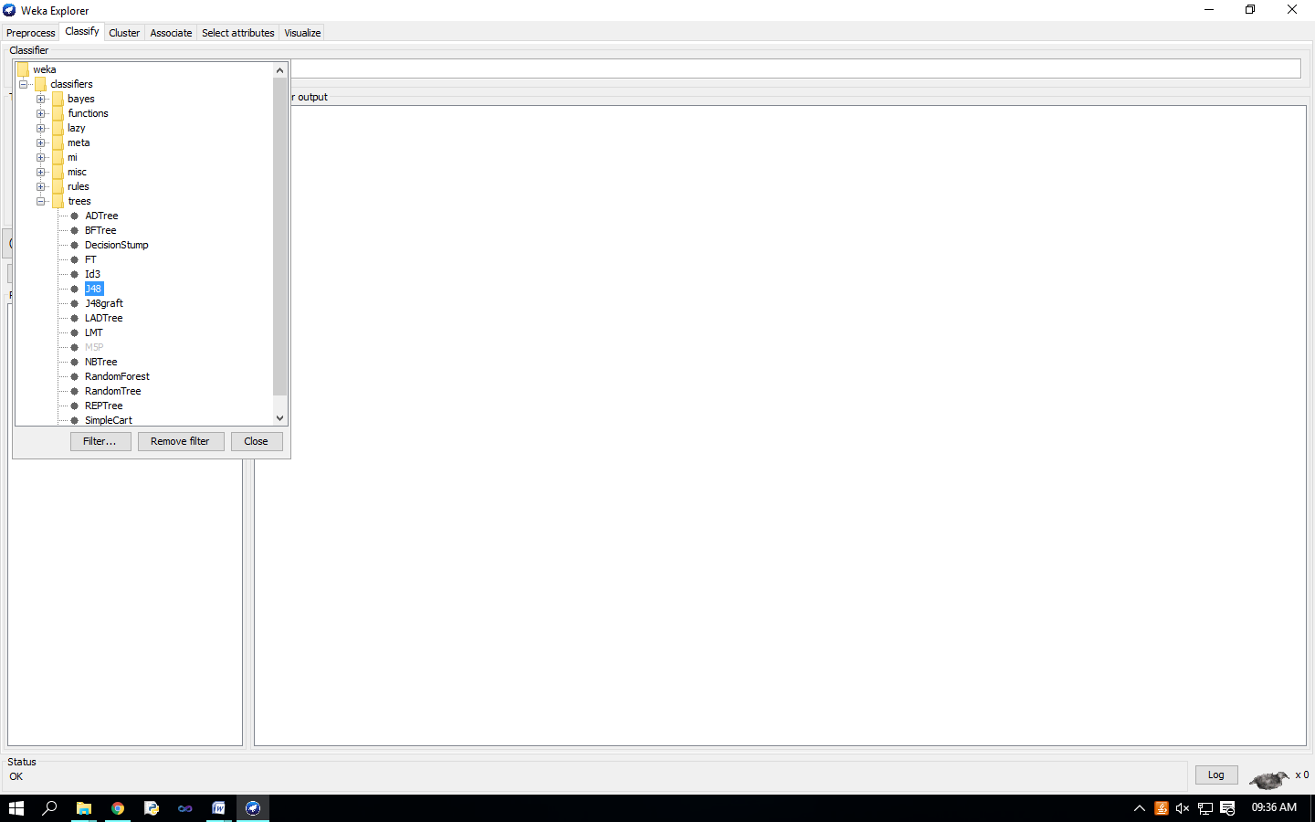 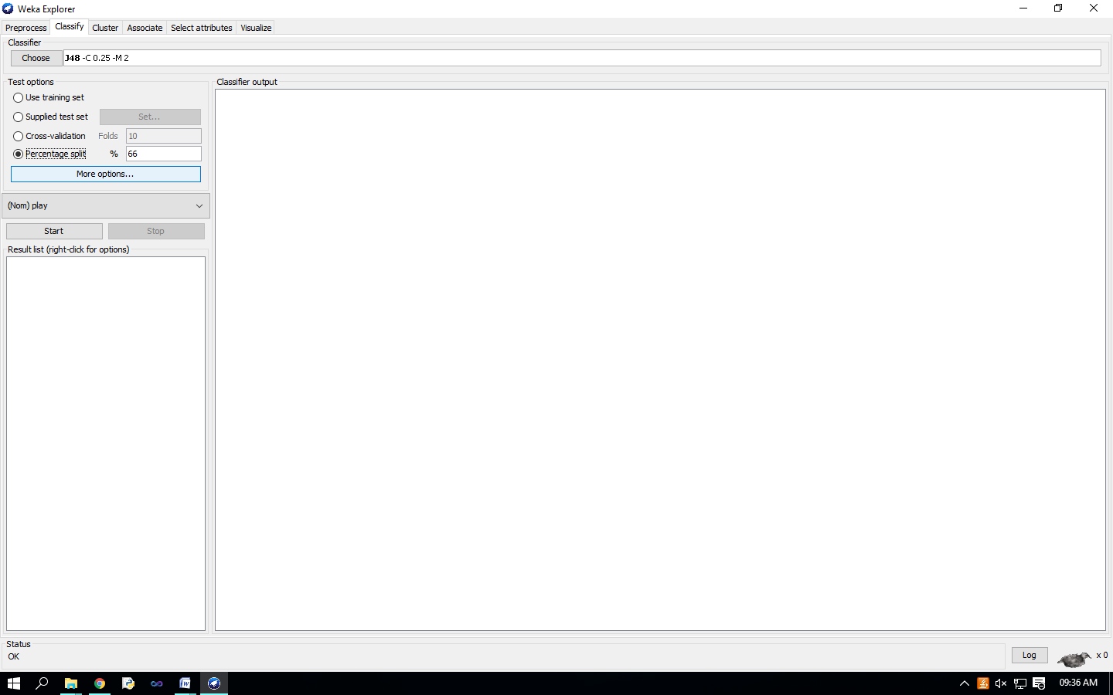

Check ‘Percentage split’ radio-button and keep it as default 66%. Click on ‘More options…’ button. make sure that the Following options are checked : 1. Output model. 2. Output per-class stats. 3. Output confusion matrix 4. Store predictions for visualization. 5. Set ‘Random seed for Xval / % Split’ to 1.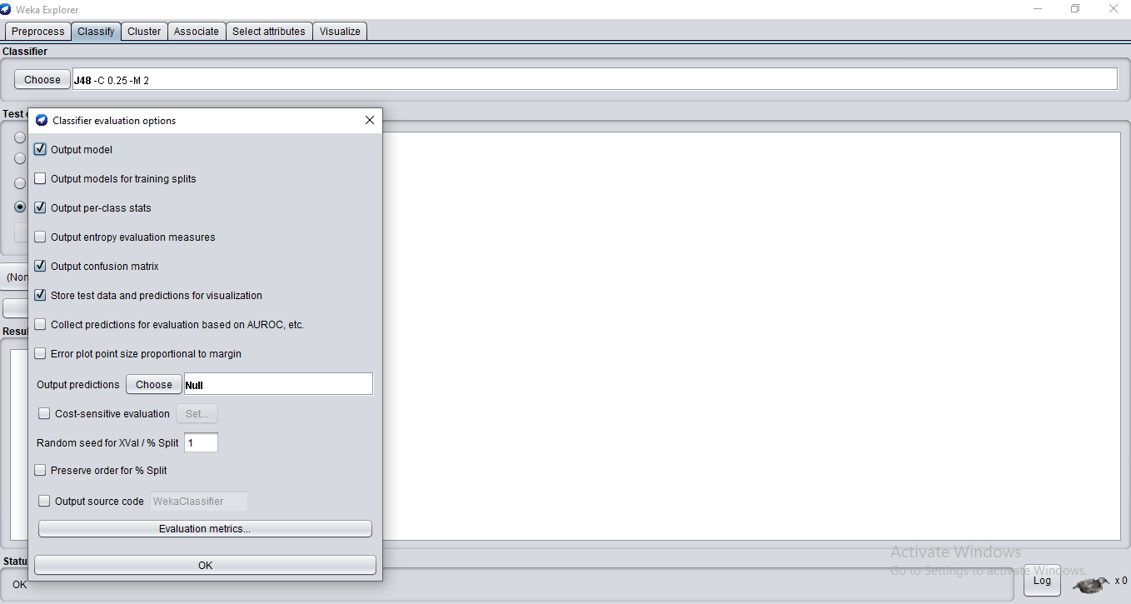

Once the options have been specified, you can run the classification algorithm. Click on ‘Start’ button 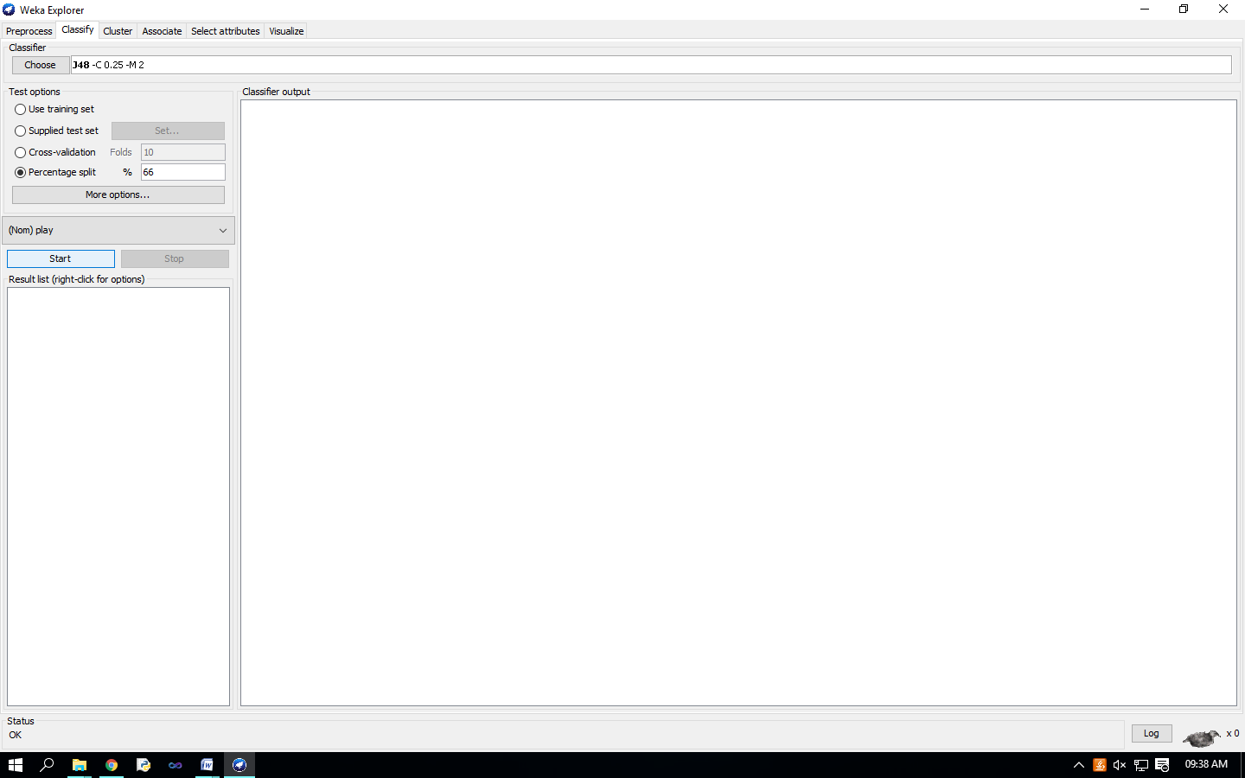 To see a graphical representation of the classification tree. Right-click on the entry in ‘Result list’ for which you would like to visualize a tree. 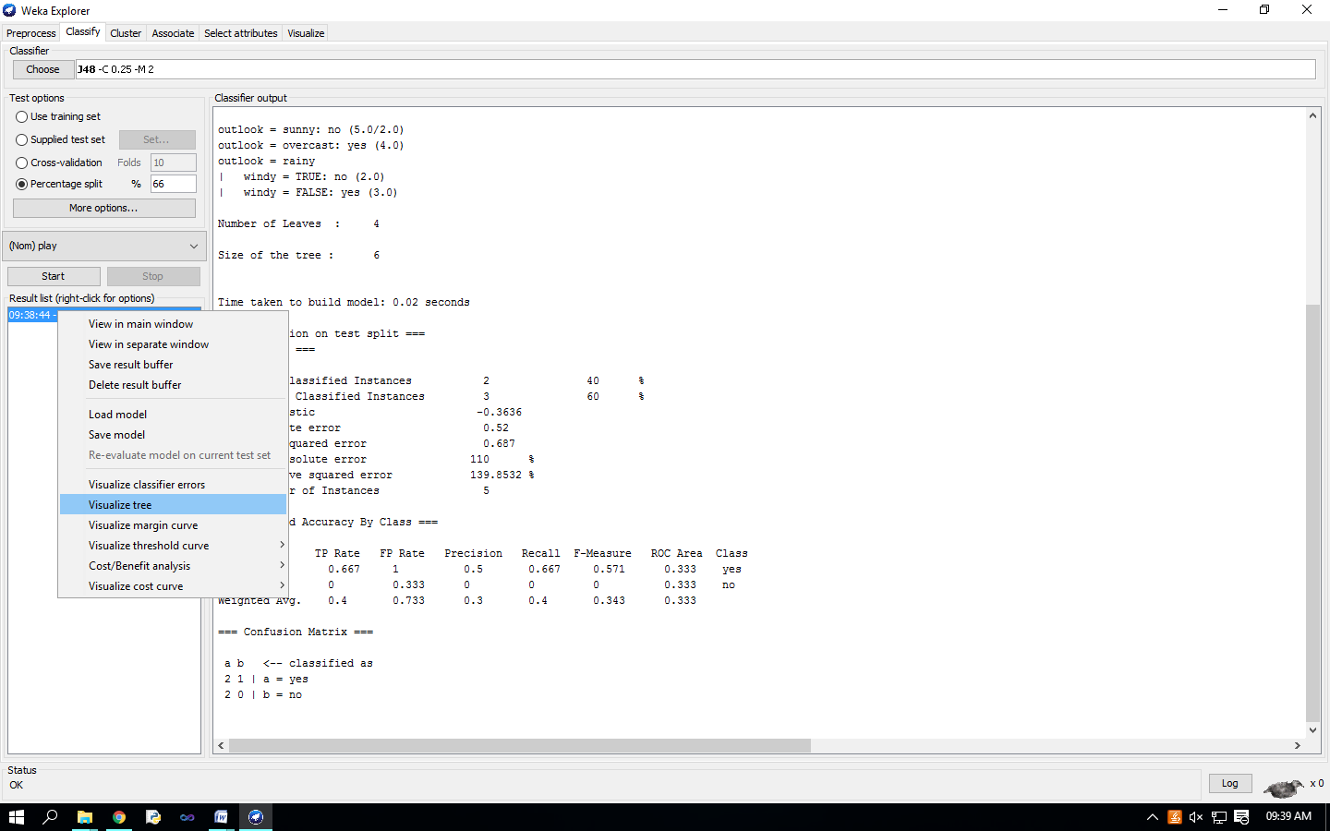 Select the item ‘Visualize tree’; a new window comes up to the screen displaying the tree.

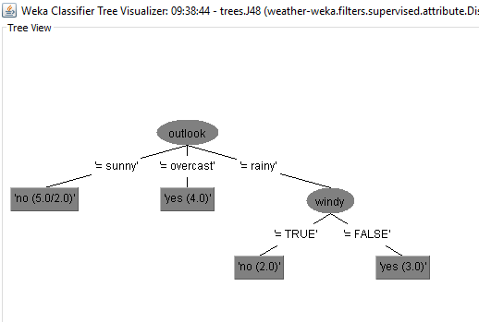

To visualize classification errors. Right-click on the entry in ‘Result list’ again and select ‘Visualize classifier errors’ from the menu: 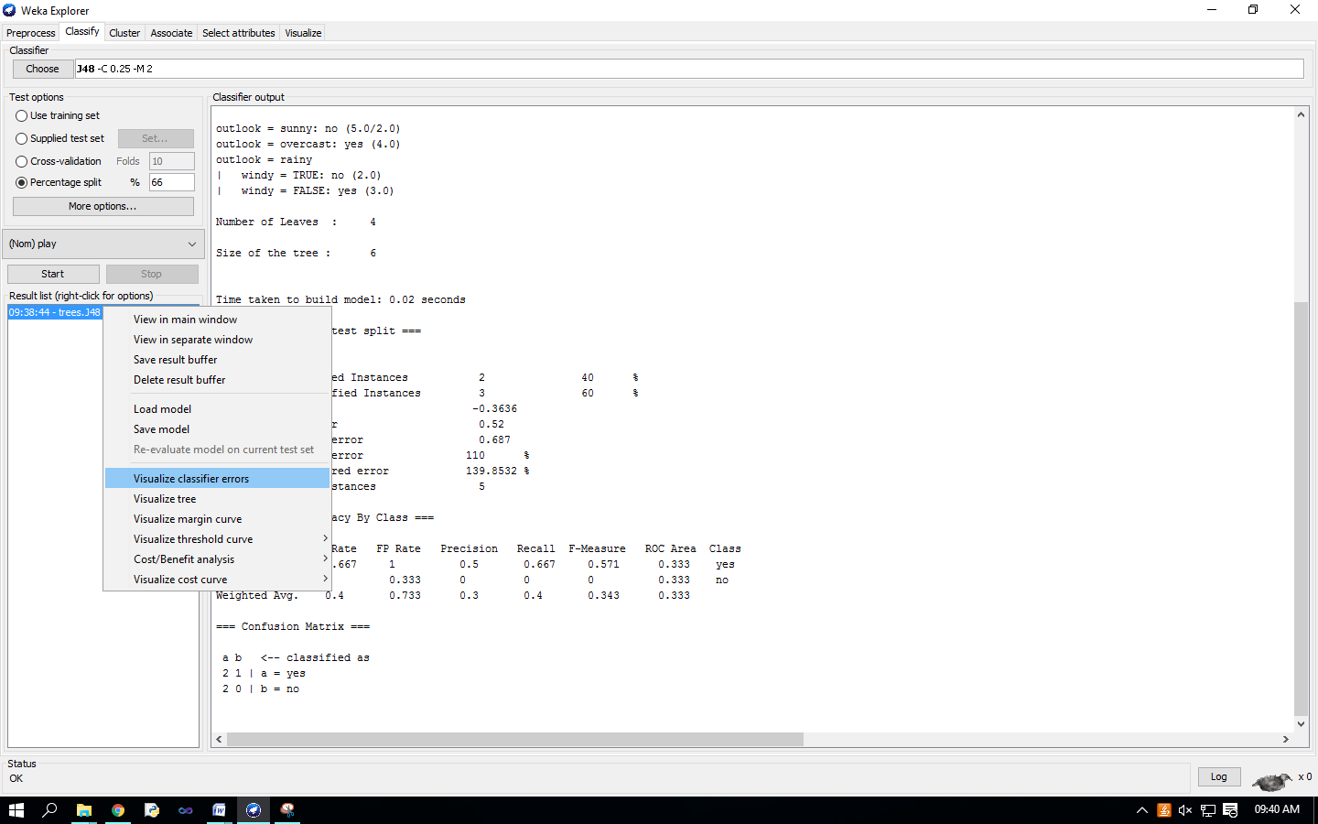 Visualize’ window displaying graph appears on the screen. 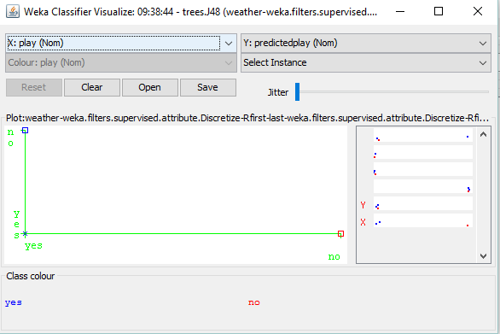

Select outlook(Nom) on X-axis.

